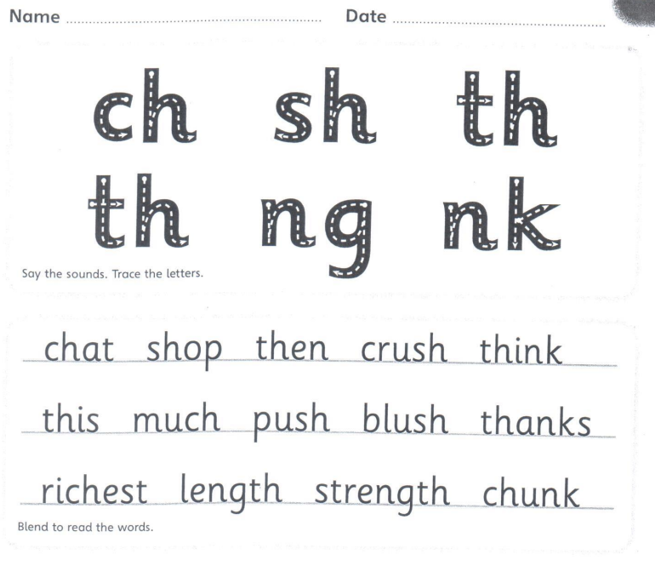
Copy the sentence out
Then, we had a chat in the richest shop.
____________________________________________________________________
Now can you put strength into a sentence.
____________________________________________________________________

